MULTILINGUAL STORY GENERATION AND SPEECH SYSTEM
Methodology, Novelty and Key Contributions
Department of Computer Science and Engineering, TKR College of Engineering & Technology
Batch C2 (CSE-C) · Academic year [ACADEMIC YEAR]
Table 1: Project team
S.No. | Student name | Roll number
1 | Lingala Sindhu | 23K91A05D3
2 | Padige Ajay | 23K91A05H8
3 | Mahek Ansari | 23K91A05D8
4 | Maheshwaram Hari Krishna | 23K91A05D9

Project guide: A Tejaswini
Chapter and section numbers quoted in the text (for example Chapter 8 or Section 6.2) refer to the full project report, 17.Final Document. Figures and tables in this document are numbered from 1.

1. METHODOLOGY
This document describes how StoryVox works from end to end and what is new in it. Part 1 gives the pipeline, the data, the algorithms and the reasons they were chosen; Part 2 sets the work against the base paper and separates what is new from what is standard; Part 3 lists the contributions.

1.1 Overall methodology
StoryVox treats story narration as a cascade of pretrained models joined by ordinary software: a language model writes the text, a speech model reads it aloud, and, for the evaluation only, a recogniser and a sentence encoder measure the result. The base paper [1] takes the opposite route for its task: it trains one end-to-end model (an mBART encoder-decoder with self-paced learning, a sparse mixture of experts and data-augmented self-training) to turn text in one language into speech in another, and reports translation quality by BLEU. StoryVox shares the goal of multilingual speech output and nothing of the method; it trains no model, so its methodology is a pipeline design and an evaluation protocol. The method has eight steps.
1. Validate. Reject an empty idea, an idea over 2,000 characters and an unknown language, style or length before any model runs.
2. Prompt. Build one instruction from the style guidance, the language name, the paragraph target and the title rule, followed by the user's idea.
3. Generate. Sample the story from Qwen3-0.6B [12] with the length-dependent token budget; use the offline composer if the model is unavailable, fails, or returns fewer than 20 words.
4. Parse and save. Take the Title: line (or a short first line) as the title and the rest as the body; count the words; store the row with the model id and the generation time.
5. Chunk and narrate. Cut the body into chunks of at most 380 characters at sentence ends, synthesise each chunk with the MMS-TTS checkpoint of the language [10], [9], normalise, join with pauses, reject silence, and fall back to the operating-system voice if needed.
6. Store and play. Write the WAV file and the audio row (duration, model id, synthesis time, real-time factor); the browser streams it.
7. Evaluate. Transcribe the narration with Whisper-small [11] and compare with the source text (WER, CER); compare the story with the idea (sentence-encoder cosine, ROUGE-L [15]); record latency and real-time factor.
8. Report. Save every run as a database row and as JSON and CSV files; show the cards, the chart, the per-sample table and the method notes.
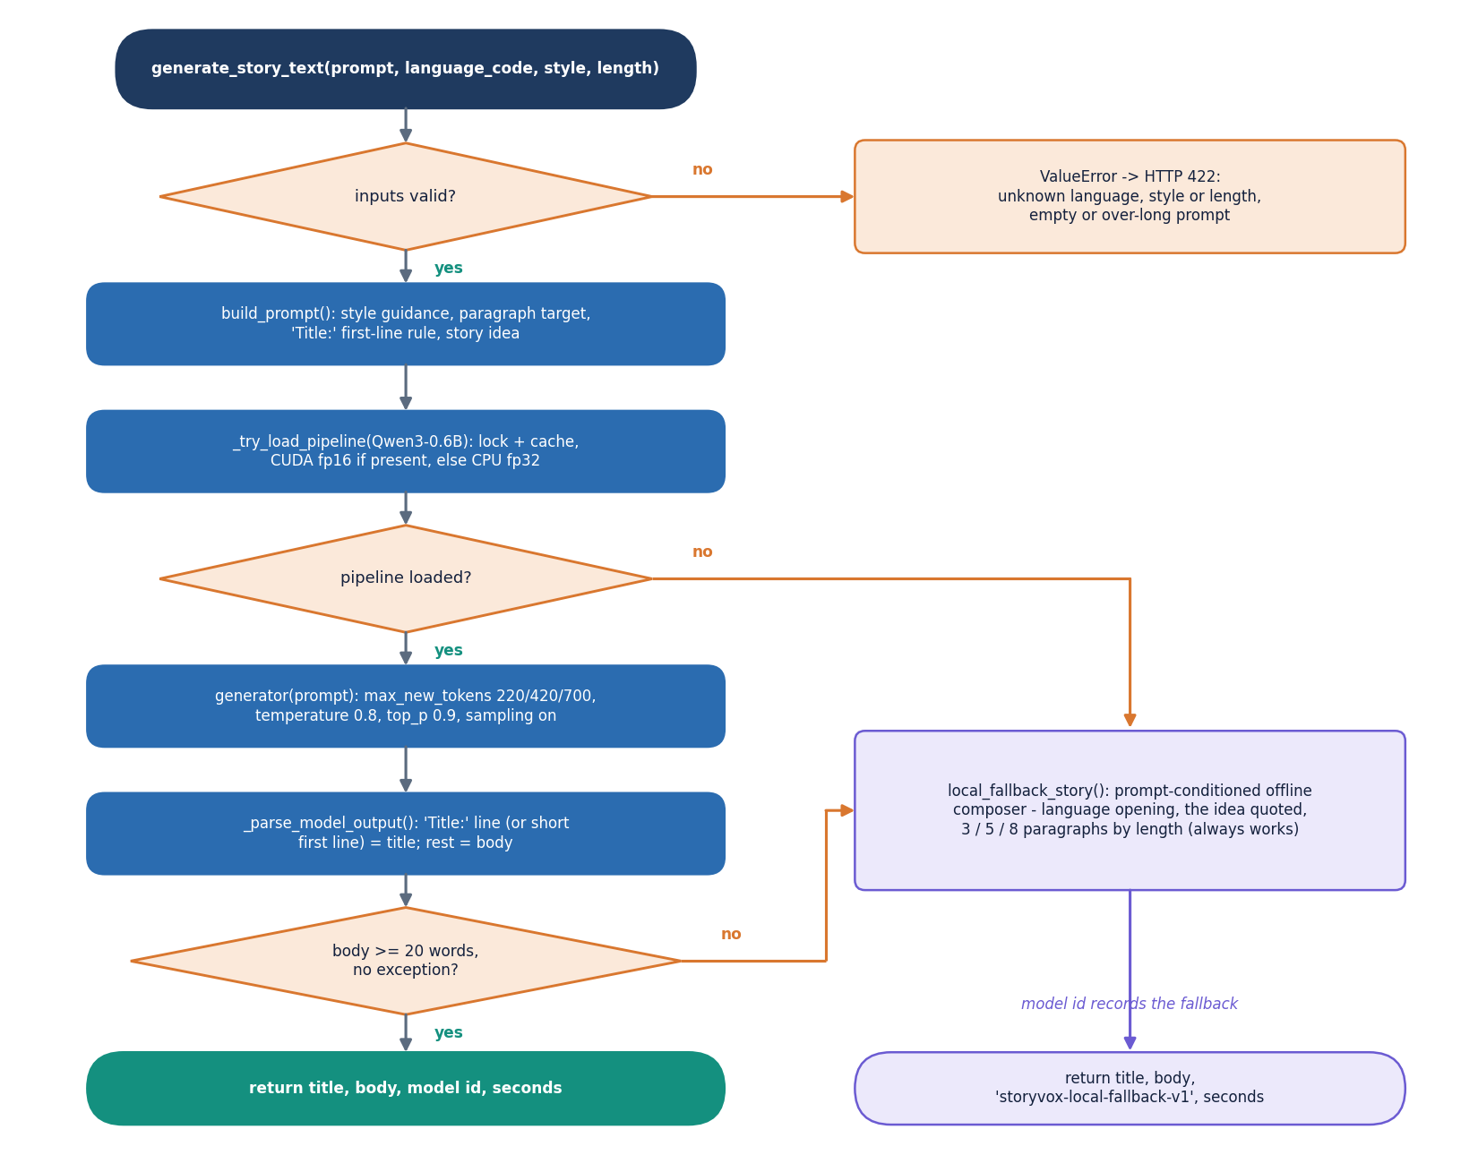
Figure 1: Flowchart of generate_story_text: validate, build the prompt, load the model once, sample, parse, check the length and otherwise use the offline composer.

1.2 Dataset
StoryVox needs no dataset to run: the input is the user's idea. Datasets appear only in the evaluation. Narration is evaluated on FLEURS [16], Google's multilingual read-speech benchmark, using the text of its test split for the 15 languages of the application (English en_us, Hindi hi_in, Spanish es_419, French fr_fr, German de_de, Italian it_it, Portuguese pt_br, Russian ru_ru, Arabic ar_eg, Turkish tr_tr, Dutch nl_nl, Polish pl_pl, Mandarin cmn_hans_cn, Japanese ja_jp and Korean ko_kr). The dataset is released under CC BY 4.0; only the raw-transcription column of the test.tsv file is downloaded from the Hugging Face dataset repository, no audio is used and nothing is stored in the project. For each language the first 10 sentences that fit a length window (6 to 30 words; 12 to 70 characters for Chinese and Japanese, which have no spaces) and are not repeated were taken, giving 150 sentences in all.
Table 2: Data used in the measurements.
Item | Value
Evaluation text | FLEURS test split, 10 sentences per language, 15 languages (150 sentences), CC BY 4.0
Story-generation experiment | One idea ('A young inventor discovers a hidden library.'), Short length, 17 items: English with Adventure, Bedtime and Mystery plus the other 14 languages with Adventure; seed 0
Length experiment | The same idea in English, Adventure, at Short, Medium and Long
Built-in evaluation prompts | Five prompts (English x 2, French, German, Spanish) in evaluation_service.default_eval_prompts
API stories | 7 stories generated through the running API (en, en, hi, fr, de, es, en) and narrated; transcribed again with chunked Whisper
Training data | None: no model was trained or fine-tuned

Three properties of this data shape every result. FLEURS sentences are short (about 8 to 14 s of speech), so the narration results describe sentences and not whole stories; story-length audio was measured separately on only seven stories. The evaluation text consists of sentences taken from Wikimedia texts, which differ from the simple narrative English that the story model writes. And the story experiment uses a single idea, so it measures how the pipeline handles one prompt in many languages, not how it handles many prompts.

1.3 Preprocessing
There is no data cleaning in the usual sense; preprocessing is the handling of text and audio on the way through the pipeline. It is implemented in app/services/* and app/utils/* and is the same in the web application, the tests and the experiments.

1.3.1 Text handling
The route strips the idea, rejects it if empty or longer than 2,000 characters, and stores the stripped text. The model's raw output is parsed by _parse_model_output: a line of the form Title: ... is taken as the title (cut at 150 characters) and the text after it as the body; if there is no such line and the first line is shorter than 120 characters and followed by more lines, that line becomes the title with its leading #, * and spaces removed; otherwise the title is Untitled Story. Runs of three or more line breaks collapse to one blank line. The word count is the number of tokens matched by a Unicode word pattern, the reading time is the word count divided by 200 words per minute, and the listening time is the audio duration (or, without audio, the word count divided by 150).
The parser is the reason for a visible defect: with the raw prompt, the model rarely writes a Title: line, so the title is often Untitled Story, and when the model repeats the instruction the parser can take the repeated text as the title (one German evaluation sample was titled with the sentence "The title should include 'Brot' and 'Berg'..."). Chapter 8 counts how often the story text itself repeats the instruction.

1.3.2 Chunking
chunk_text collapses whitespace and splits at the end of a sentence (a full stop, question mark, exclamation mark, the Devanagari danda or the ideographic full stop followed by a space) and then packs whole sentences into chunks of at most 380 characters. A single sentence longer than the limit is cut into pieces of 380 characters (a 1,000-character word run becomes pieces of 380, 380 and 240 characters, which a unit test checks). Languages written without spaces after a full stop, such as Chinese or Japanese, therefore usually end up as one long sentence that is cut at 380 characters, possibly in the middle of a word.

1.3.3 Audio handling
Each chunk is synthesised separately. Its waveform is scaled so that its largest absolute value is 0.9, which levels the chunks against each other; the chunks are joined with 0.25 s of silence between them at 16,000 Hz; the result is rejected if its root-mean-square value is below 1e-4 (silence). Audio from the operating-system voice is read back from its temporary file, mixed to mono and resampled to 16 kHz by linear interpolation. The final signal is written as 16-bit PCM WAV.

1.3.4 Normalisation for scoring
The application's own WER and CER compare the story text and the transcript as they are, so capitalisation and punctuation count as errors. The experiments report these as the raw values and add normalised values: Unicode NFKC, lower case, punctuation and symbols removed, spaces collapsed, and for Chinese and Japanese the spaces removed altogether. For English the corpus-level normalised WER is 20.6% against a mean raw sentence WER of 26.2%; the normalised figures are the ones quoted in this report unless stated.

1.4 Prompt construction and sampling
The only control StoryVox has over the story is the prompt. build_prompt produces one string; for the idea used in the experiments it is exactly the text below (the line break is added for printing):
Write an original adventure story in English, full of discovery, movement, and courage. Target length: short (about 3 short paragraphs).
Start the first line with 'Title: ' followed by a short evocative title, then a blank line, then the story body only. Story idea: A young inventor discovers a hidden library.

Table 3: The controls that the prompt and the configuration expose.
Control | Values | Effect
Style (8) | Adventure, Fantasy, Educational, Bedtime, Mystery, Inspirational, Funny, Custom | A fixed phrase is inserted: for example 'full of discovery, movement, and courage' (Adventure) or 'calm, soothing, and comforting with a peaceful ending' (Bedtime)
Length (3) | Short, Medium, Long | Paragraph target 3, 5, 8 in the prompt; token budget 220, 420, 700 new tokens
Language (15) | en, hi, es, fr, de, it, pt, ru, ar, tr, nl, pl, zh, ja, ko | The language name is inserted in the prompt; the same code selects the speech checkpoint
Sampling | temperature 0.8, top-p 0.9, sampling on | Set in the environment; the same for all lengths

The prompt is passed to the text-generation pipeline as raw text, without the chat template that Qwen3 was tuned to expect, and return_full_text is false so that only the continuation is returned. This matters. A small instruction-tuned model given an instruction as plain text tends to continue it as a document, which in our runs produced instruction-like sentences ("The story should end with...") and text about the story rather than the story. To measure the effect the experiments add a second condition (B) that wraps the same prompt in the chat template with thinking disabled; it is not part of the product. In the 17 items, the share of sentences that repeat the instruction fell from 9.7% (condition A, as shipped) to 0.7% (B).
Sampling uses torch.manual_seed(0) in the experiments so that runs can be repeated; the product sets no seed. With the same seed, condition A produced almost the same English text for most languages, because the language word changes only a few tokens of a long prompt; the 17 items therefore show how often the model follows the language instruction, but they are not 17 independent stories.

1.5 Algorithm choice and justification
The choices were made for a machine without a graphics card. Qwen3-0.6B [12] is the smallest Qwen3 language model; it fits in 1.5 GB on disk and generates 9.1 tokens per second on the test CPU, which makes a three-paragraph story a matter of seconds and not minutes. MMS-TTS [10] offers one small VITS model [9] per language (145 MB each), so adding a language adds a file and not a retraining; VITS is a single-pass generator, which is why the mean real-time factor is 0.25. Whisper-small [11] is multilingual and, being used only to judge the narration, does not need to be the best recogniser. The multilingual MiniLM encoder [14] compares a prompt with a story in any of the 15 languages.
Larger systems were not used. OmniVoice [6] and XTTS [26] cover more languages or clone voices, but they are much larger models and running them on this CPU-only machine was outside the project, and the base paper's end-to-end model [1] was trained for 1.5 to 2 days on an A100 graphics card; we did not look for released weights. Whether the small choices are good enough is a measured question, and the measurements below show that the speech half is, while the text half is not.
Table 4: Story-generation conditions on the 17 items (Short length, same idea).
Measure | A: shipped (raw prompt) | B: chat template | C: offline composer
Mean latency (s) | 22.7 | 21.5 | < 0.001
Mean words | 178.6 | 152.6 | 96.3
Tokens per second | 9.14 | 9.28 | n/a
Story in the requested language | 17.6% | 47.1% | 17.6%
Sentences that repeat the instruction | 9.7% | 0.7% | 2.9%
Distinct-2 (variety) | 0.788 | 0.957 | 0.907
Idea-story similarity (MiniLM) | 0.549 | 0.580 | 0.680
ROUGE-L, idea vs. story | 0.054 | 0.045 | 0.135

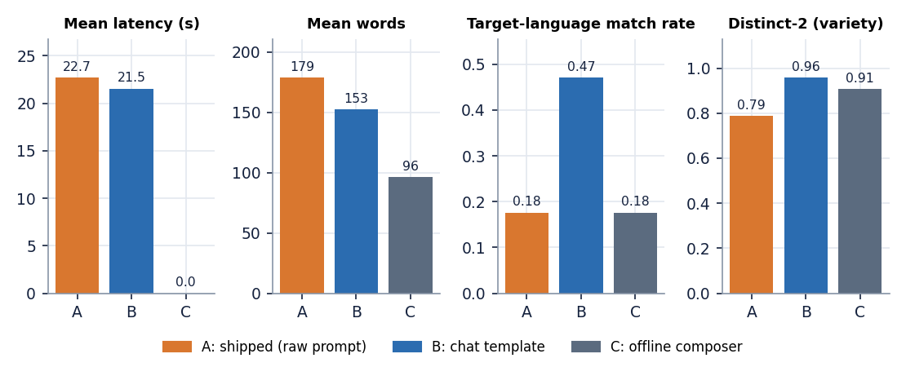
Figure 2: Four measures of the three story-generation conditions on the 17 items.
Three readings follow. The language instruction is mostly ignored: with the shipped prompt only 18% of the stories were detected as being in the requested language (the English ones); the chat template raises this to 47%, still below half. The composer scores highest on similarity (0.68) only because it quotes the idea word for word, which is why similarity to the prompt cannot be read as quality. Speed is the same for A and B because the same model and token budget are used. The language detector is itself unreliable on very short or mixed text, so the match rates are indicative, not exact.
For speech the corresponding evidence is in Chapter 8: 12 languages are narrated by MMS-TTS with a mean normalised CER of 8.8% after a round trip through Whisper-small, and the best and worst are Spanish (2.1%) and Hindi (17.9%). This mixes the error of the speech model with that of the recogniser, whose own error on natural speech was not measured separately, so the speech figures are upper bounds on the narration error.

1.6 Mathematical formulation

1.6.1 Sampling
The language model gives, at each step, a score z_i to every token i of its vocabulary. With temperature T the probabilities are p_i = softmax(z / T). Nucleus sampling [21] keeps the smallest set V of tokens whose probabilities add up to at least top-p, renormalises inside V and draws the next token from it:
p_i = exp(z_i / T) / sum_j exp(z_j / T), V = smallest set with sum_{i in V} p_i >= top-p, token ~ p_i / sum_{j in V} p_j (1)
StoryVox uses T = 0.8 and top-p = 0.9. A higher temperature flattens the distribution and makes the text more varied and more error-prone; a lower one makes it repetitive.

1.6.2 Narration
Let the text be cut into chunks x_1 ... x_m and let s_k be the waveform of chunk k at 16,000 Hz. Each waveform is scaled to a peak of 0.9 and the chunks are joined with a pause of 0.25 s of zeros, so the duration of the narration is
s'_k = 0.9 * s_k / max|s_k|, audio = s'_1 || 0 || s'_2 || 0 || ... || s'_m, duration D = ( sum_k len(s_k) + (m - 1) * 0.25 * 16000 ) / 16000 (2)
The real-time factor is the synthesis time divided by the duration; values below 1 mean faster than real time:
RTF = T_synth / D (3)

1.6.3 Intelligibility metrics
For a reference text r and a recogniser transcript h, the word error rate is the word-level edit distance divided by the number of reference words; the character error rate is the same at character level:
WER = (S + D + I) / N_words(r), CER = (S + D + I) / N_chars(r) (4)
S, D and I are the substitutions, deletions and insertions of the minimum edit alignment. The application computes WER and CER with jiwer for each sample and averages them; the experiments also report a corpus value in which the edit counts and the reference lengths are first summed over all sentences of a language, which weights long sentences more and is the figure used for the language tables. WER can exceed 1 when the transcript is much longer than the reference.

1.6.4 Similarity and variety metrics
The idea-story similarity is the cosine of the sentence embeddings u (idea) and v (story) of the multilingual MiniLM encoder [14]; if the encoder cannot be loaded, the application falls back to a cosine of word-count vectors and says so in the row. ROUGE-L [15] is the F-measure of the longest common subsequence of the two texts. Distinct-2 is the share of different word pairs among all word pairs of a story (characters for text without spaces), a simple measure of repetition. The instruction-echo ratio is the share of the sentences of a story that contain a phrase from a fixed list of instruction fragments (for example 'the story should', 'blank line', 'title:').
cos(u, v) = u . v / (|u| |v|), Distinct-2 = |unique bigrams| / |bigrams|, echo = (sentences matching a fragment) / (all sentences) (5)
The language-match rate is the share of stories for which the langdetect library names the requested language. It was applied to texts of 100 to 200 words; it is reported as an indicator because the library can mislabel short or mixed-script text.

1.7 Model architecture and inference configuration
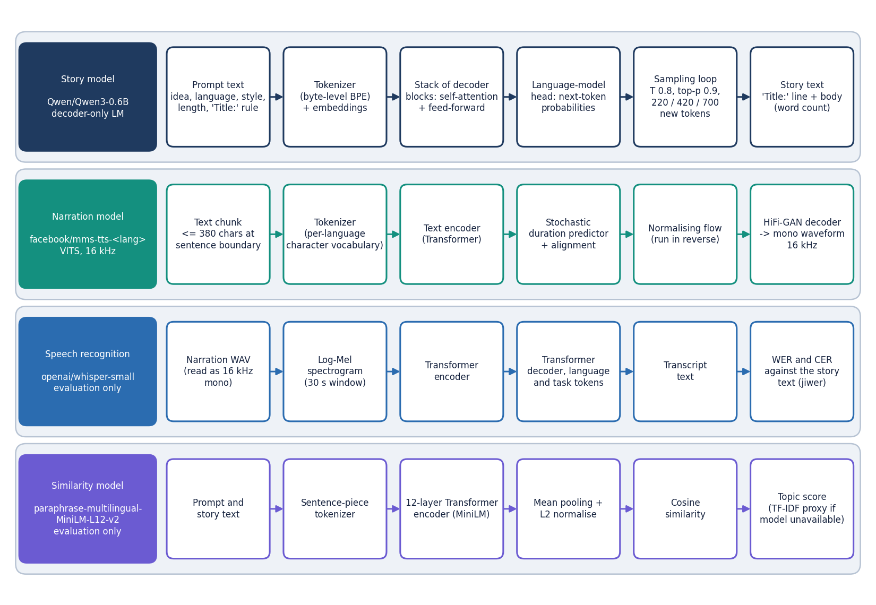
Figure 3: The four pretrained models used by StoryVox, each shown as its processing chain: Qwen3-0.6B, MMS-TTS (VITS), Whisper-small and multilingual MiniLM.
No model was trained or fine-tuned in this project, so there are no training curves, no loss, no learning rate and no hyper-parameter search to report. What the project fixes is the way pretrained models are run; the table lists every setting.
Table 5: Models and their inference settings.
Model | Role | Settings
Qwen/Qwen3-0.6B | Story text | transformers text-generation pipeline; float32 on CPU (float16 if CUDA is found); sampling on; temperature 0.8; top-p 0.9; max new tokens 220 / 420 / 700; raw prompt; loaded once under a lock (4.4 s from the cache)
facebook/mms-tts-* | Narration | VITS checkpoint chosen by language; tokenizer from the same repository; 16 kHz output; chunks of at most 380 characters; peak 0.9; pause 0.25 s; first load 1.8 s from the cache, 19 to 25 s when downloaded; one model per language kept in memory
System voice (pyttsx3) | Fallback narration | Operating-system voice at rate 170, text cut at 4,000 characters, WAV read back and resampled to 16 kHz; only English voices (David, Zira) existed on the test machine
openai/whisper-small | Recogniser (evaluation) | Transformers speech-recognition pipeline; language forced to the story language; task transcribe; no chunking in the product (chunk_length_s = 30 in the story-audio experiment); load 6.6 s
paraphrase-multilingual-MiniLM-L12-v2 | Similarity (evaluation) | Sentence-transformers encoder with normalised embeddings; re-created at every evaluation sample in the product; in the experiments loaded once

Two implementation details have consequences. The text pipeline is created with trust_remote_code=True, which allows code from the model repository to run at load time; this is a security trade-off, and we did not test whether the model loads without it. And the speech tokenizer for some languages (Korean) needs the uroman romaniser, which is not in requirements.txt; without it Korean text reaches the tokenizer unconverted.

1.8 Evaluation protocol
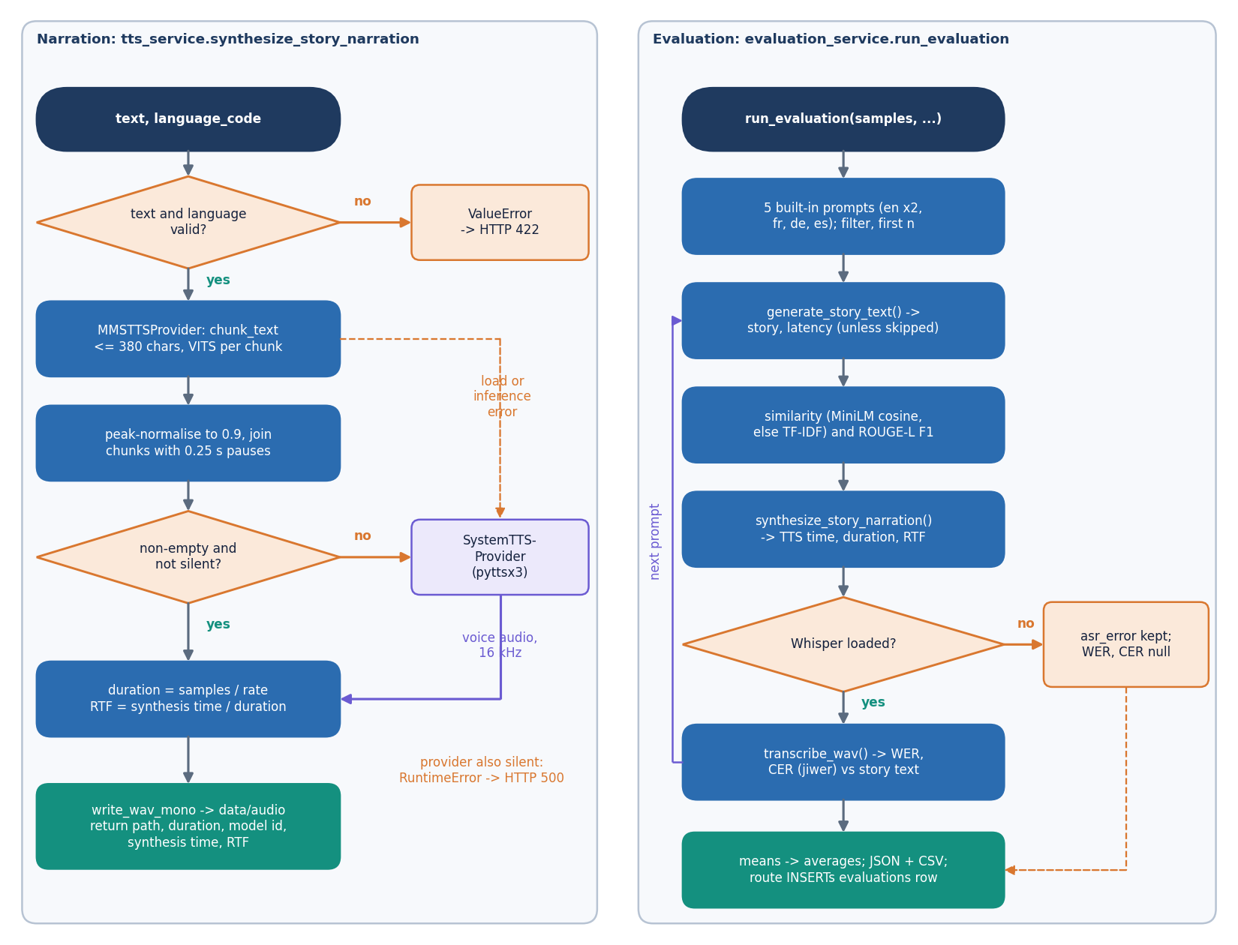
Figure 4: Left: the narration provider chain with its silence check and fallback. Right: the evaluation loop that produces WER, CER, similarity, ROUGE-L and RTF.
The protocol has five parts, each implemented by a script that calls the application's own services so that the numbers describe the shipped behaviour.
1. Narration round trip (scripts/run_experiments.py tts_asr). For each language, 10 FLEURS sentences are narrated through synthesize_story_narration, transcribed by Whisper-small with the language forced, and scored against the source sentence. The first sentence of a language is not discarded; model-load time is measured separately.
2. Chinese and Japanese fallback (run_experiments.py cjk). Because no MMS checkpoint exists for these two languages, each sentence is narrated in its own child process with a 90 s limit (the operating-system engine can hang on text it has no voice for) and scored the same way; 2 of 10 Chinese and 1 of 10 Japanese sentences were narrated.
3. Story generation (run_experiments.py story). The 17 items are generated under conditions A, B and C and scored with the measures of Section 6.6; a second part generates the Short, Medium and Long English story with condition B and narrates each with MMS (36.8, 60.4 and 79.9 s in total).
4. API measurement (scripts/measure_api.py). A running server is called 10 to 30 times on each cheap endpoint and seven times on POST /api/stories/generate with narration; the first call is cold. The seven stories remain in the database and feed the screenshots.
5. Story-length intelligibility (scripts/run_story_asr.py). The seven API stories and their WAV files are transcribed with chunked Whisper (30 s windows) and scored with normalised WER and CER, because the application's own evaluation cannot score audio longer than 30 s.
The application's built-in evaluation (POST /api/evaluations/run) was also run twice through the API (5 samples and 2 English samples) to populate the Evaluation page; both runs report WER and CER as empty, for the reason in Chapter 8. Tests are run with scripts/run_tests.py, which stores the pytest outcome (29 of 29 passed). The environment was CPU-only (Intel Core i5-12500, 15.7 GB), Python 3.11.9, PyTorch 2.14.1, Transformers 5.20.2, with other jobs running on the same machine, so timings are indicative.
Limits of the protocol. The narration scores include the error of the recogniser, which was not separated. Only ten sentences per language were used, so differences of a few points between languages are within the noise (for example, the 12 MMS languages range from 2.1% to 17.9% CER). No human listened to the audio and no human rated a story, so naturalness, coherence and narrative quality were not measured; the automatic story measures are proxies. One idea and one seed were used for the story experiment.
Figure 5: Model architecture of StoryVox: story model, speech model and recogniser in one local pipeline.
Figure 6: Flowchart of the core algorithm, with the leakage guards marked.

2. NOVELTY AGAINST THE BASE PAPER

2.1 What the base paper contributes
The base paper [1] is SAM Translator. SAM Translator replaces the shared feed-forward layers of an mBART text-to-unit model with a sparse mixture of eight experts (top-2 routing, load-balancing loss alpha = 0.001), trains with a self-paced curriculum (threshold tau starts at 2 and grows by 0.25 every 2,000 steps until all samples are used), and adds filtered synthetic pairs for six low-BLEU languages (5K, 10K and 15K pairs). Speech units come from HuBERT-Base with K-means (K = 200, 50 units per second), and Grad-TTS turns units into audio. Evaluation transcribes the output with a wav2vec 2.0 recogniser and reports BLEU. It reports consistent gains for each of its three ideas on CVSS-C and CoVoST-2, a listener study, and an honest list of limitations: low BLEU for some languages, repetition and meaning errors, a target language that is always English, no content control, and a training cost of one A100 GPU for about one and a half to two days.

2.2 What is new in StoryVox
StoryVox does not propose a new algorithm, and none of its models was trained or tuned in this project. What is new is the system and what was learned by measuring it:
• One local pipeline from idea to narrated, stored, evaluated story. The batch literature treats story generation and speech synthesis separately, or reaches them only through a cloud service. StoryVox joins an instruction-tuned language model [12] and per-language VITS speech models [9], [10] behind one interface (the TTSProvider abstraction), stores every story and recording in SQLite, and runs on a CPU laptop with no data leaving the machine after the one-time download.
• Offline degradation paths. When the story model fails or answers with too little text, a prompt-conditioned composer in all 15 languages still answers; when a language has no speech model, an operating-system voice is used. Both paths exist in the shipped code and were exercised in the experiments, which also shows what they cost in quality.
• A built-in evaluation harness. The application can score its own output: it narrates, transcribes with Whisper-small [11], and reports WER, CER, RTF, similarity and ROUGE-L, and it stores each run. The documentation run added a larger harness around it (150 speech round trips, 51 stories under three conditions, story-length recognition, API timing) and 21 automated tests.
• Measured findings about a small multilingual cascade. The experiments give numbers that the base paper cannot give for its different task: narration is fast (mean RTF 0.25) and readable (12 languages, mean CER 0.088), but a 0.6-billion-parameter story model with the shipped prompt wrote English for 4 of 4 non-English live requests, which makes the narration of those stories unintelligible (WER 0.60 to 1.34). These findings point at the prompt format and the missing language check as the first things to fix.

2.3 What is standard
Everything in the models is used as published: the Transformer [18], the Qwen3 model family [12], VITS [9] and the MMS speech checkpoints [10], Whisper [11], multilingual sentence embeddings [14], WER and CER by edit distance, ROUGE-L [15] and the FLEURS benchmark [16]. Sampling uses temperature 0.8 and top-p 0.9, the nucleus setting recommended against degenerate text [21]. The Hugging Face libraries [17] supply the model loading. Nothing here is a new method.

2.4 What the base paper has and StoryVox does not
• No translation model and none of the base paper's techniques. There is no self-paced learning, no mixture-of-experts layer, no data-augmented self-training and no discrete speech units; StoryVox trains nothing. The base paper's BLEU gains on translation therefore say nothing about StoryVox, and StoryVox's WER and CER say nothing about SAM Translator (The base paper reports BLEU on CVSS-C / CoVoST-2 for translation into English; StoryVox reports TTS-to-ASR round-trip WER/CER, real-time factor and story-level checks on its own small test sets. The numbers measure different things on different data and must not be compared.)
• No subjective evaluation. The base paper asked ten listeners to rate naturalness; StoryVox collected no human rating of story or voice.
• No ablations of the pipeline's own design. The only controlled comparison is the three story conditions (shipped prompt, chat template, offline composer) and the per-language speech comparison; there is no comparison of different story or speech models.
• No reference benchmark for the stories. The speech half is evaluated on a public corpus (FLEURS); the story half has no reference corpus, so its evaluation consists of proxies and of reading the text.

3. KEY CONTRIBUTIONS
The contributions of the project, stated at the strength the evidence supports, are:
1. StoryVox, a working local pipeline: a story idea, in one of 15 languages, eight styles and three lengths, becomes a stored story and a WAV narration through a FastAPI service with 11 routes, a SQLite store of three tables and a five-page React interface, with an offline composer and an operating-system voice as fallbacks.
2. A speech round-trip measurement of the narration stage: 150 FLEURS sentences in 15 languages through the application's own narration and Whisper-small, with raw and normalised WER and CER and the real-time factor (mean RTF 0.25 and mean CER 0.088 on 12 MMS languages).
3. A controlled comparison of three ways to write the story (shipped prompt, chat template, offline composer) on 17 requests, showing that the shipped path matched the requested language in 3 of 17 and the chat template in 8 of 17, and that similarity scores reward a composer that quotes the idea.
4. The language-mismatch finding for narration: English text read by a foreign voice is unintelligible (WER 0.60 to 1.34; 4.4 s of audio for 185 Hindi-requested words), against WER 0.25 and CER 0.21 for English stories with an English voice.
5. Defects found and documented, not hidden: three speech checkpoints that do not exist, an undeclared ffmpeg and uroman dependency, an evaluation page that cannot compute WER or CER for any real story, a title parser that misses bold titles, and an instruction-echo failure of the shipped prompt, each with the evidence and a proposed fix.
6. A tested, reproducible artefact: 29 passing automated tests (21 added), measurement scripts (run_experiments.py, measure_api.py, run_story_asr.py, run_tests.py) that regenerate every number in the documents, a screenshot script that drives the real interface, and a facts file from which the documents are built.

